**Lab #7 (Lab 09a) - Implement Web Apps**

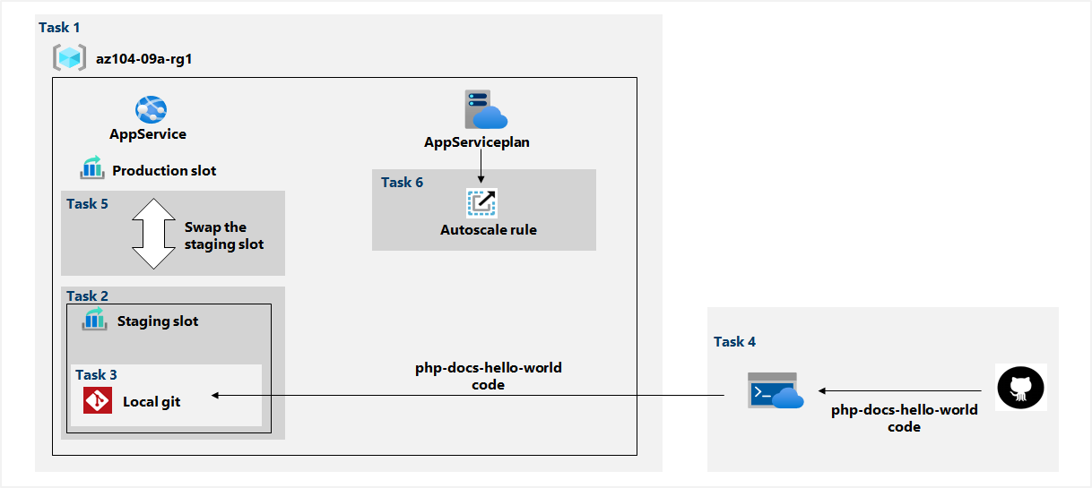

**Task 1: Create an Azure web app**

In the first step of this lab we are creating web app through the app services, we click create and configure the basics, the operating system is Linux and PHP runtime stack.

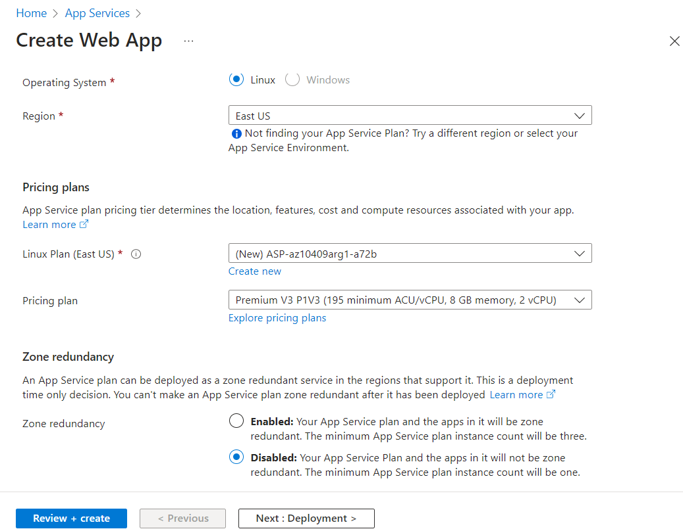

The web app is created and we need to go to resources.

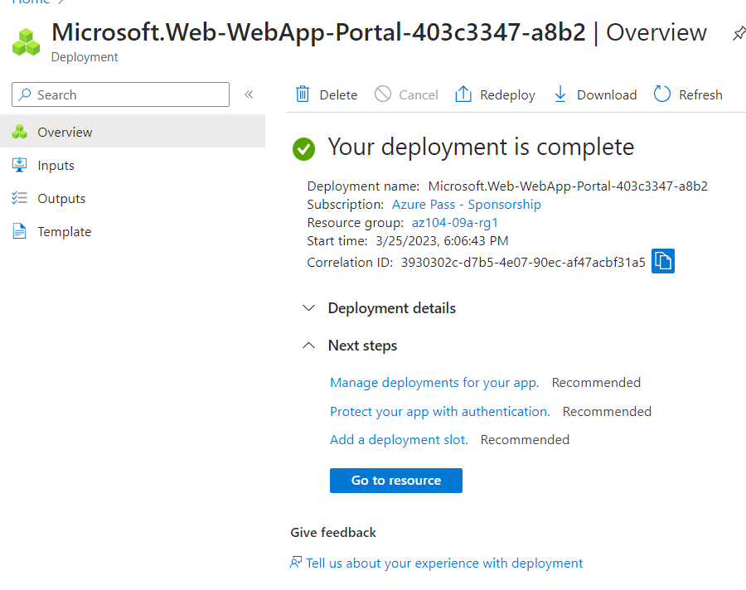

**Task 2: Create a staging deployment slot**

We open the URL link from the web app in new browser tab to display the default web page.

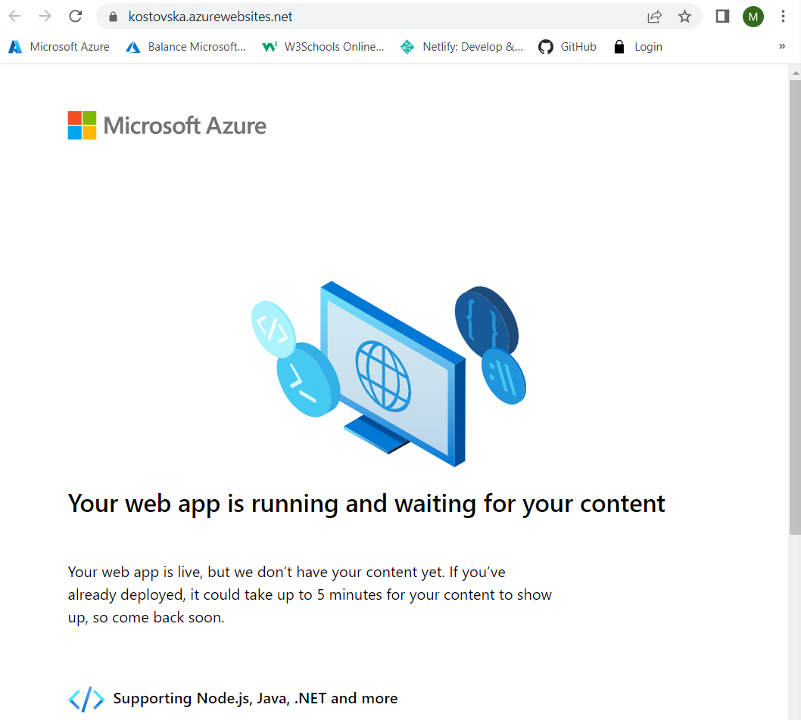

In the deployment section we are adding a new slot - staging

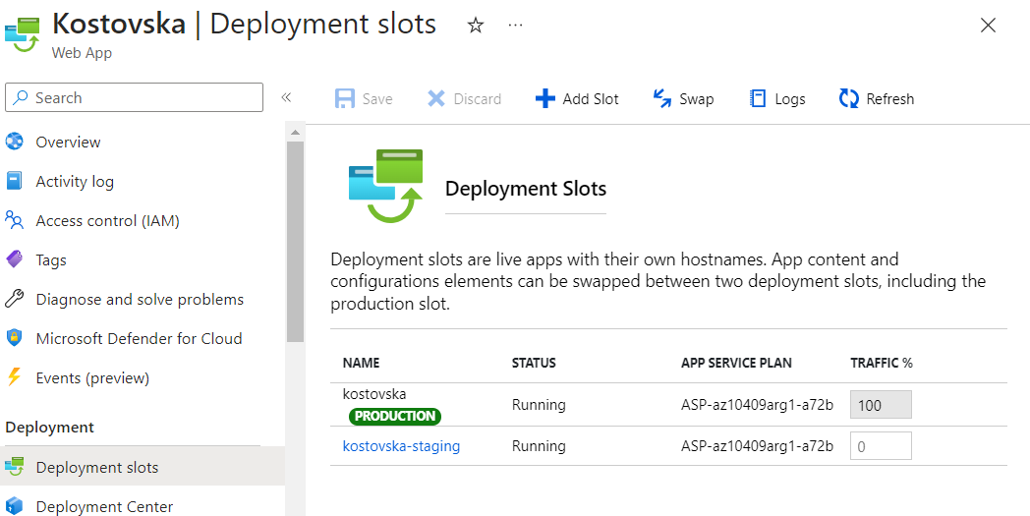

The new staging slot is created and its URL differs from the one assigned to the production slot.

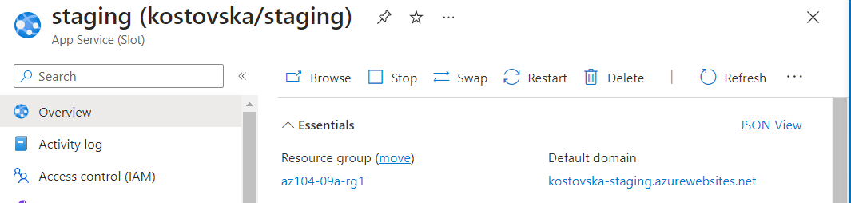

**Task 3: Configure web app deployment settings**

In the staging deployment we change the source settings to local git

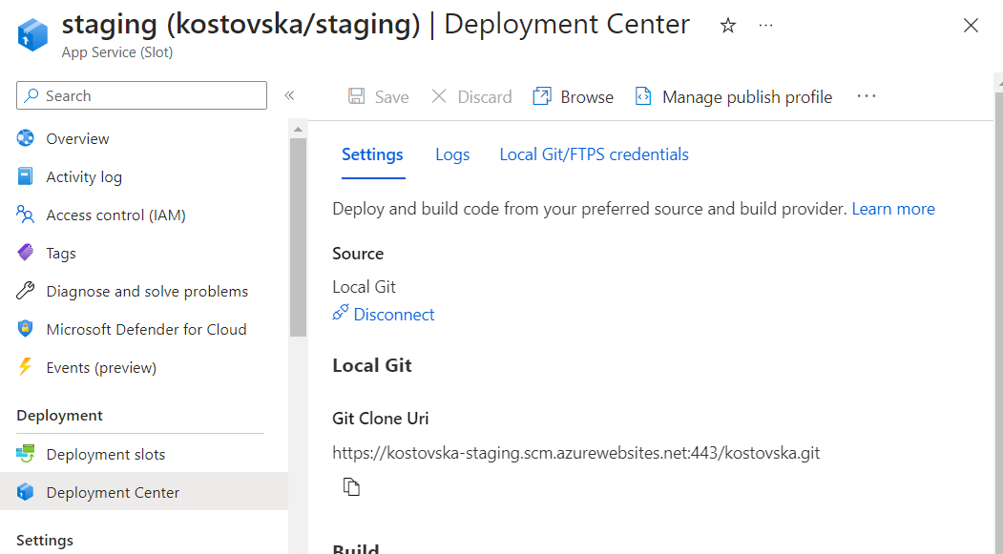

In deployment center blade we select local git and create new credentials

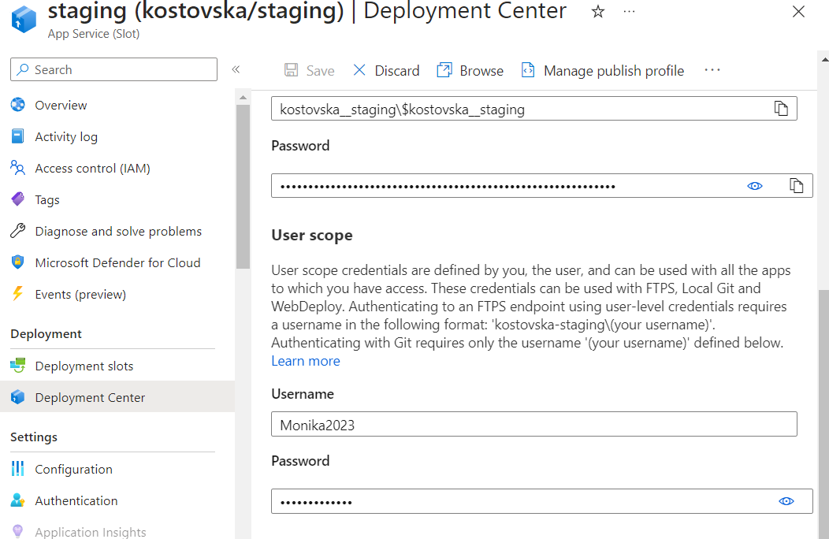

**Task 4: Deploy code to the staging deployment slot**

From the cloud shell we clone the remote repository containing the code for the web app.

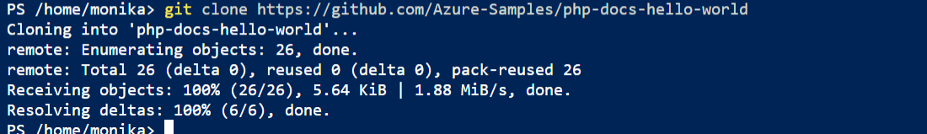

and set the current location to the newly created clone of the local repository



adding the remote git



Pushing the sample web app from local repository to azure web app - staging deployment slot





From overview we can get the url link and open the web page in new tab, we can check if it’s successful if the result is Hello World!

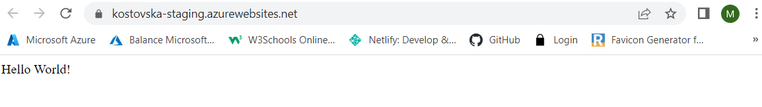

**Task 5: Swap the staging slots**

From Deployment/ Deployment slots we can swap the staging slots

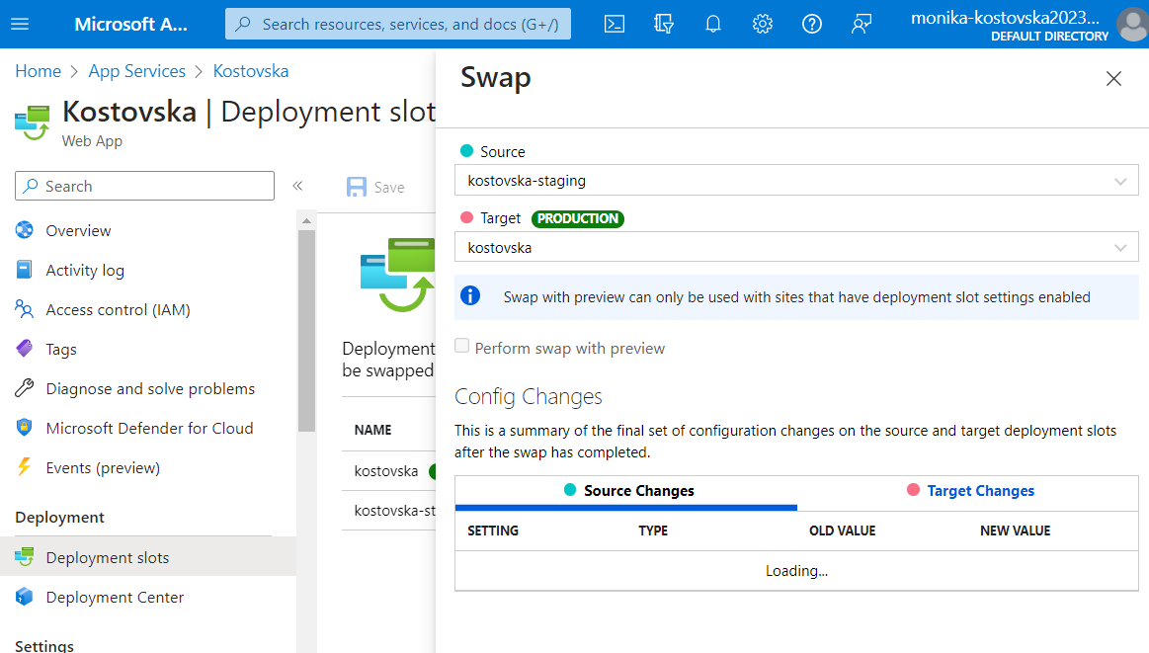

We can make sure if that was completed by opening the url link from the overview

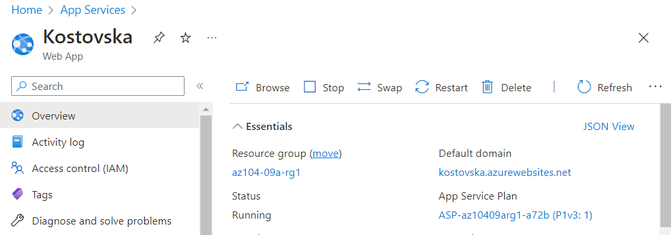

and verify that the default web page is replaced with Hello World page

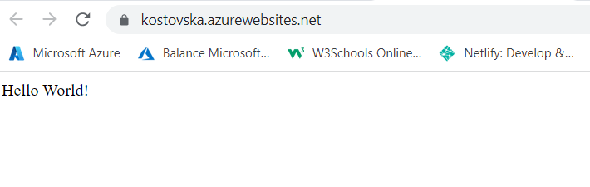

**Task 6: Configure and test autoscaling of the Azure web app**

In the production slot (Kostovska production) we configure the app plan to scale out, we scale based on a metric and add a new rule with the provided settings

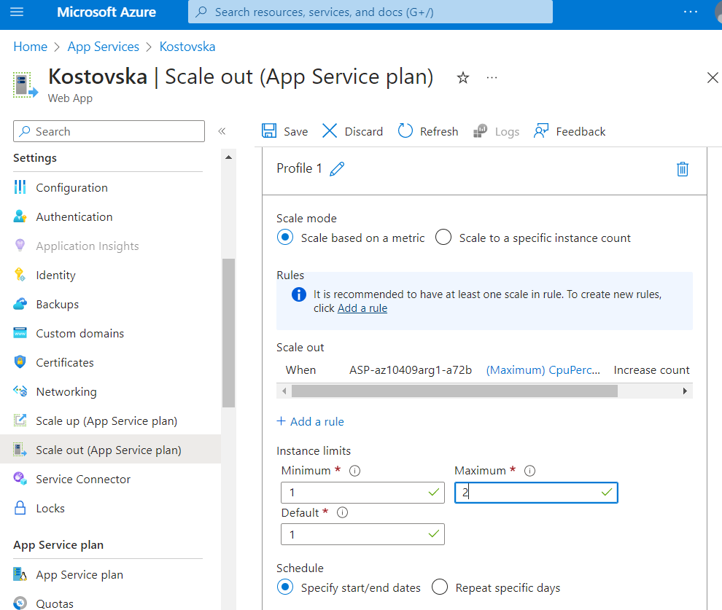

After we save the configuration we run a code in power shell to identify the URL of the azure web app and create an infinite loop with HTTP requests that are sent to the web app, after few minutes the number of instances will increase from 1 to 2.

